Erik Marrero

CS 152-01

Homework 3

4/5/2020

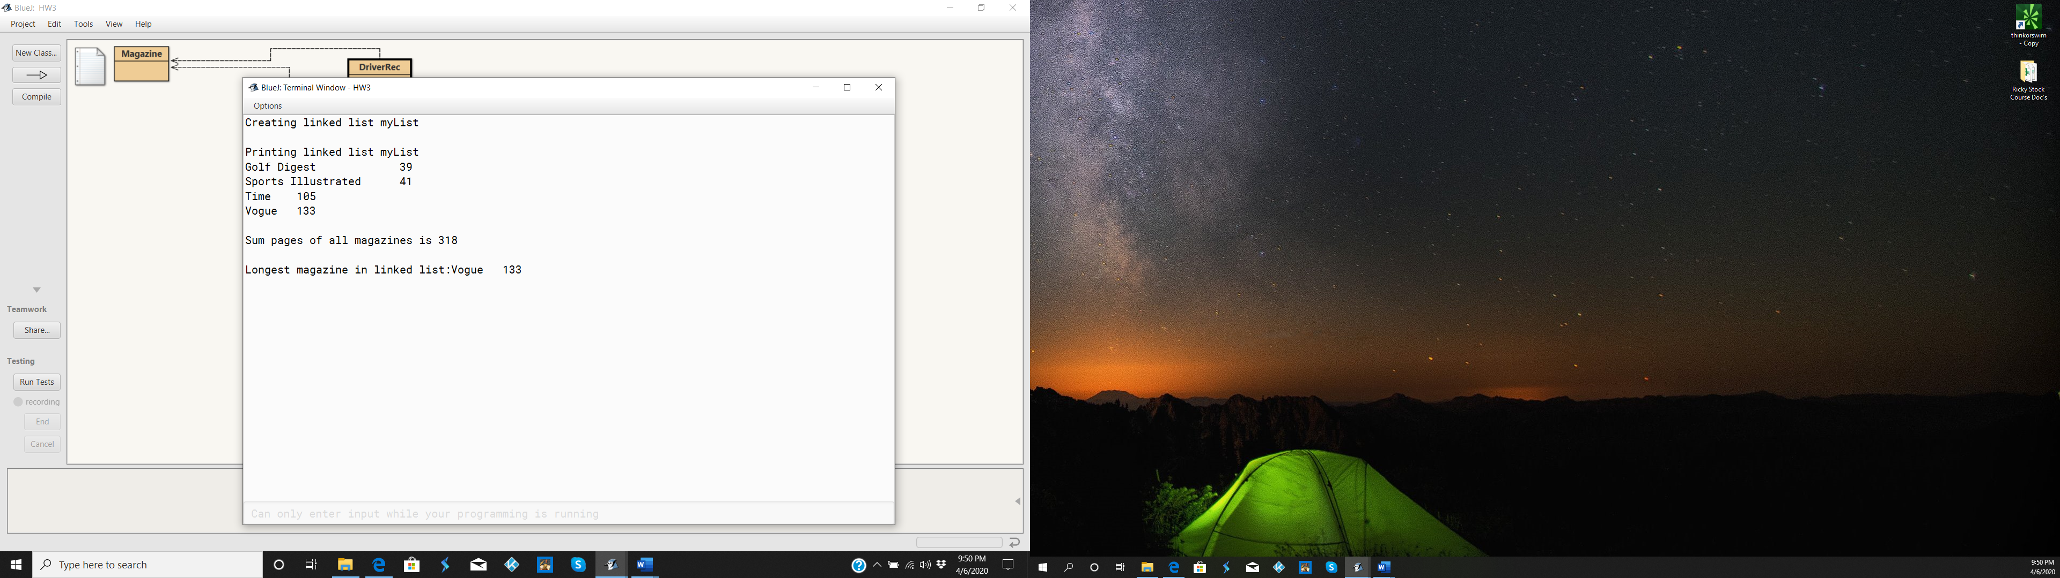

public class LLMagazineRec

{

private Node list;

public LLMagazineRec()

{

list = null;

}

public Node getList()

{

return list;

}

public void addRear(Magazine mag)

{

Node node = new Node(mag);

if (list == null)

list = node;

else

{

Node curr = list;

while (curr.next!= null)

curr= curr.next;

curr.next = node;

}

}

//Prints data in each node in the linked list.

//Method is recursive, and works for empty and non-empty list.

public void printLLRec(Node first)

{

if (first == null)

return;

else

{ System.out.println(first.data.toString());

printLLRec(first.next);

}

}

//Returns sum of pages of all magazines in linked list.

//Method is recursive, and works for empty and non-empty list.

public int sumAllPagesRec(Node first)

{

int int_v = 0;

if (first != null)

int_v = first.data.getPages() + sumAllPagesRec(first.next);

return int_v;

}

//Recursive method returns longest magazine in linked list

//PRECONDITION list is not empty

public Magazine longestMagRec(Node first)

{

if (first == null)

return list.data;

else

{

Magazine magazine_var = longestMagRec(first.next);

if (magazine_var.getPages() > first.data.getPages())

return magazine_var;

else

return first.data;

}

}

private class Node

{

public Magazine data;

public Node next;

public Node(Magazine mag)

{

data = mag;

next = null;

}

public String toString()

{

return data.toString();

}

}

}

public class Magazine

{

private int pages;

private String name;

public Magazine(int p, String n)

{

pages = p;

name = n;

}

public int getPages()

{

return pages;

}

public String getName()

{

return name;

}

public boolean equals(Magazine mag)

{

return (mag.getPages() == pages &&

mag.getName().equals(name));

}

public boolean isLong()

{

return pages > 100;

}

public String toString()

{

return name + "\t" + pages;

}

}

public class DriverRec

{

public static void main(String[] args)

{

System.out.println("Creating linked list myList");

LLMagazineRec myList = new LLMagazineRec();

myList.addRear(new Magazine(39, "Golf Digest\t"));

myList.addRear(new Magazine(41, "Sports Illustrated"));

myList.addRear(new Magazine(105, "Time"));

myList.addRear(new Magazine(133, "Vogue"));

System.out.println("\nPrinting linked list myList");

myList.printLLRec(myList.getList());

System.out.println("\nSum pages of all magazines is " +

myList.sumAllPagesRec(myList.getList()));

System.out.println("\nLongest magazine in linked list:" +

myList.longestMagRec(myList.getList()));

}

}